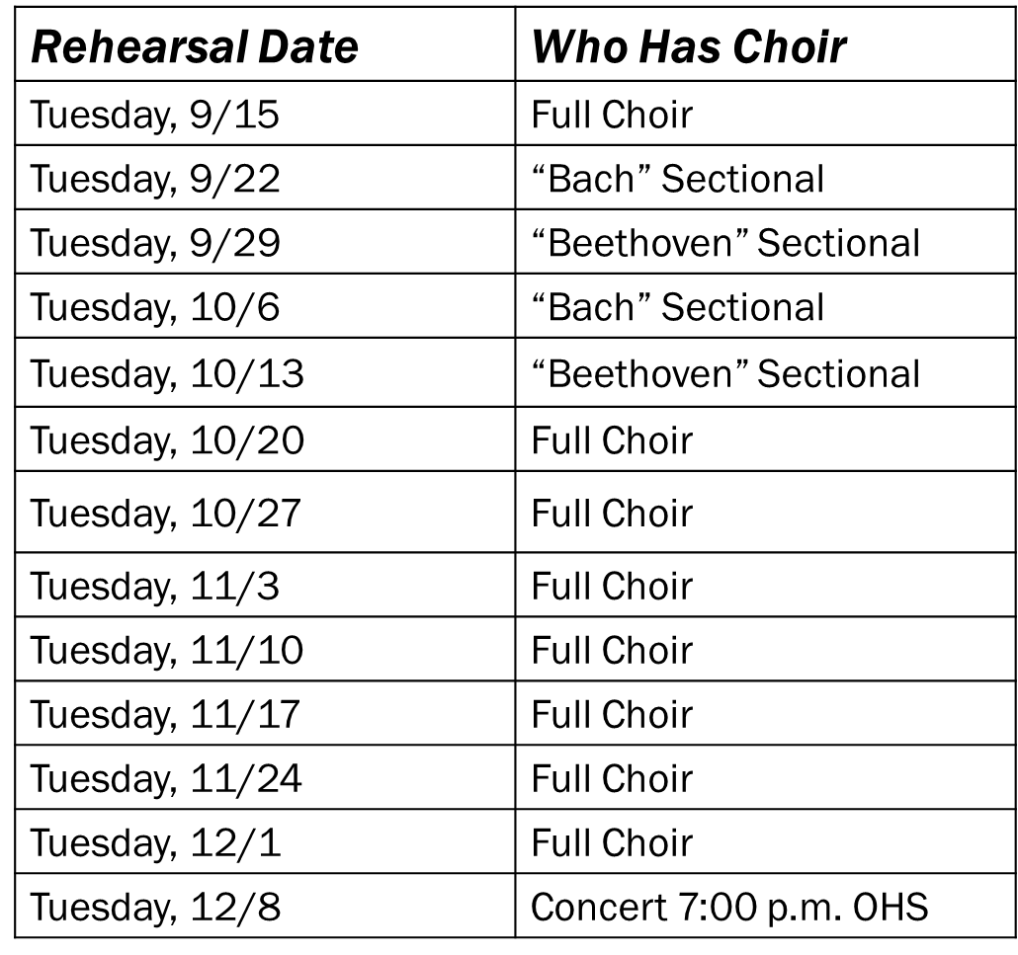

Washington Choir Schedule  
**September-December 2015**  
Questions? Contact Dana Spears 444-8323  
dspears@owatonna.k12.mn.us